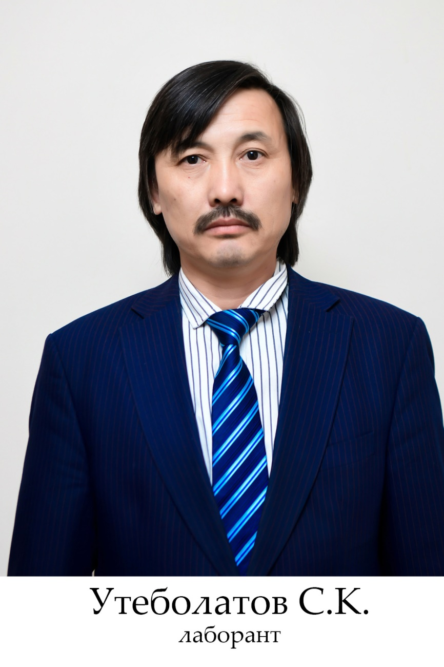

**Utebolatov Samat Kenesovich**

**Utebolatov Samat Kenesovich-lobarant**

Education: Higher

Mobile communication:: 8(778) 4264775

Born on December 24, 1975 in Akbastau settlement, Tole bi district.

In 1985-89, he studied at the akbastau Music School in the piano class.

In 1996-2000 he graduated from the International Kazakh Turkish university named after In 1996, he became a prominent member of the folklore and ethnographic ensemble" Kazygurt", which plays five instruments.

From 2000 to 2012, he worked as a labor teacher at school No. 75 in Shymkent.

Since 2012, he has been a master of the circle "National Instrument making" of the South Kazakhstan State Pedagogical University.

**Awards:**

In 1997, he became the main prize-winner of the International Festival of song and dance of the Turkic peoples in Yalova, Turkey.

On the pages of regional and Republican newspapers, notes about Samat's work appeared in publications.

SKSPU was awarded the 80th anniversary badge

Grand Prize-winner of the Regional Song Contest "Uklim-AI", held in 2000, 3rd Prize-winner of the International Song Contest Shamshi Kaldayakov.

Winner of the 1st place of the city competition "Onerli Ustaz", winner of the regional competition "Onerli Ustaz", awarded with letters of thanks from the city and regional departments of Education.H. A. Yasawi with a degree in "Organization of cultural and leisure activities".