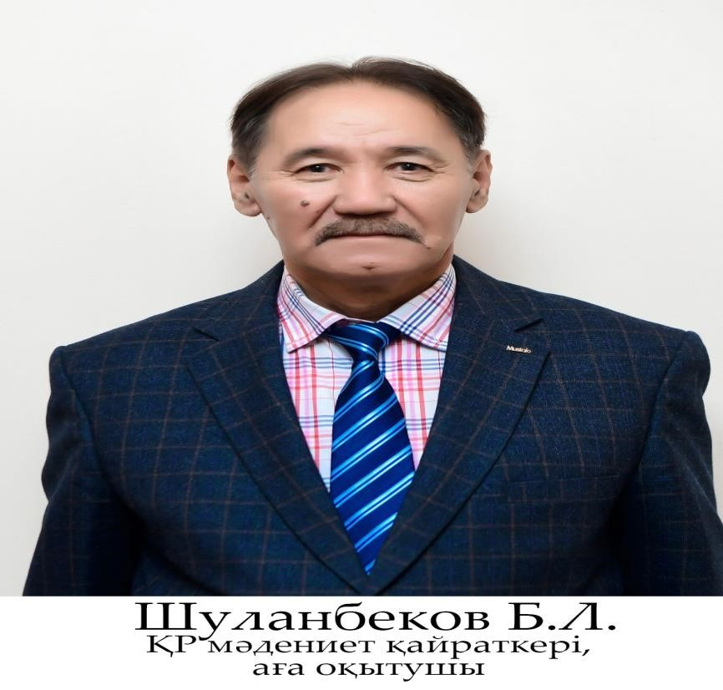

Sultanbekov Berkinbay Latifovich.

Email:berkinbay_52@mail.ru

Mobile phone: +7 701 455 53 42

Education: Higher

education, 1970. Tolebiysky district. OM No. 2 named after Sh . Ualikhanov.

1973-1977 - Shymkent Pedagogical Institute, graduated with a degree in Fine Arts and Drawing.

1991-1995 - Almaty Pedagogical Institute named after Abai. He graduated from the graduate school of the Faculty of Fine Arts.

Scientific works:

More than 48 scientific papers have been published, including 3 textbooks, 15 methodological manuals, about 30 articles published in collections of scientific papers of international, regional, republican scientific and practical conferences.

Since 1977, he has participated in international, republican and regional creative exhibitions, has received many diplomas and letters of thanks.

Work experience:

Total work experience: 47 years.

Since 1972 - 45 years in the direction of pedagogical, scientific, scientific and methodological, as well as artistic and creative work.

1970 - employee of the Department of Culture of the Lenger Tolebiysky district.

1971-1973 – was in the ranks of the Soviet army, "GSVG" was in the ranks of the GDR.

1979-2011 In addition, he was the head of the sports and recreation camp "Teacher" in the Mash at George.

1990-2008 - Chairman of the MSTU trade union organization.

2008-2011 - Chairman of the AIU trade union.

2011-2020 - Chairman of the KSPU trade union.

2016-2020 - Chairman of the organization "Ardagerler".

1977-2022 - currently senior lecturer at the Department of Vocational Training and Fine Arts of SKSPU

Awards:

2006 - Honored Worker of Culture of the Republic of Kazakhstan.

2012 - Order of Merit.

2015 - Kazakhstan branch of the "Professional Union of Education and Science Workers", badge. Badge "For services to the trade union".

In 2016, he was awarded a diploma of the regional Department of Education and the regional maslikhat.

2016 - The Order of OKMPU "80 years".

2016 - Medal "For Services to the Trade Union of Education and Science Workers".

2017 - Medal "Honored Worker of Education of the Republic of Kazakhstan" 2019 - "Veteran of Labor" of the Ministry of Education and Science of the Republic of Kazakhstan

2022 - "Honored Veteran" No. 129, Turkestan region, Shymkent.