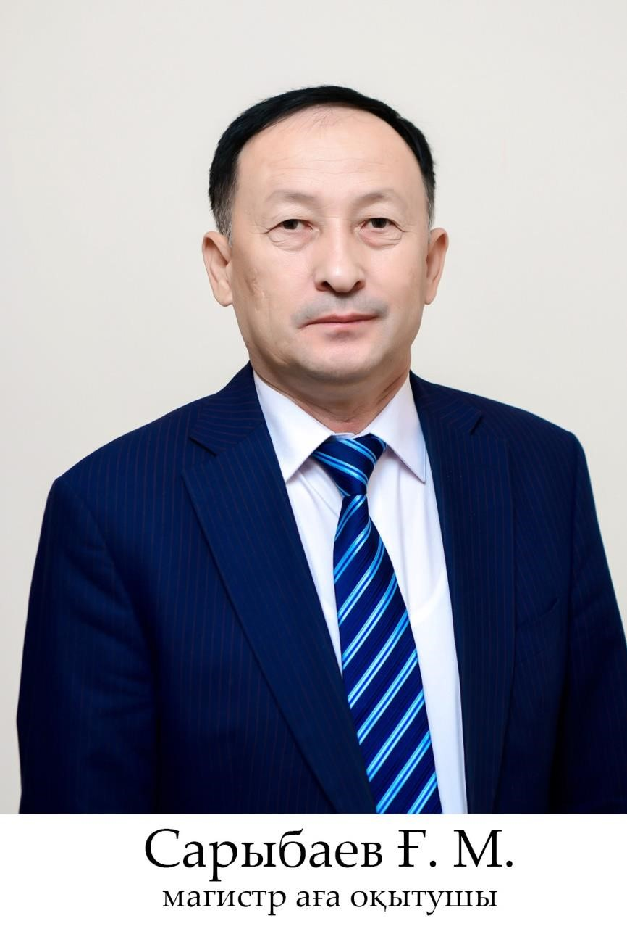

**Sarybayev Galymzhan Myrzaseitovich**

Sarybayev Galymzhan Myrzaseitovich– Master of Pedagogical Sciences, senior lecturer.

Email: [gsarybayev@mail.ru](mailto:gsarybayev@mail.ru);

Mobile communication: 8 702 266 46 40

**Education: Higher**

He graduated from high school in 1986.

1987-1989. was in the ranks of the Soviet army.

1989 - 1994 He graduated from the M. Auezov Pedagogical Institute of the Kazakh-Turkish International University named after K. A. Yassawi.

Specialization: General technical subjects and work.

6M012000-Master of Pedagogical Sciences in the specialty vocational training.

Scientific papers: more than 30 scientific and methodological papers have been published.

Work experience: 29 years.

1993-1995 Teacher of general technical subjects of secondary school No. 32 named after M. Auezov.

1995-2009 Teacher of general technical subjects of Shymkent City Higher Vocational School (VPU-5).

2009-2012 Shymkent Socio-Pedagogical Institute. Teacher of the Department of Fine Arts and Professional Education.

2012-2018 Regional Socio-Innovative University. Senior lecturer of the Department of "Vocational Training and Art". By the decision of the Academic Council of the Regional Socio-Innovative University dated October 31, 2018 (Protocol No. 3), he was awarded the title of associate professor of the University.

2018-2020 Worked as an associate professor at the regional socio-innovative University. 2020-2021 Senior Lecturer at SILKWAY International University.

Since 2021, he has been working as a senior lecturer at the Department of Vocational Training and Fine Arts of the South Kazakhstan State Pedagogical University.

Awards: He was awarded letters of thanks, awards and greeting cards for his great contribution to the development of the education system of the Republic of Kazakhstan.