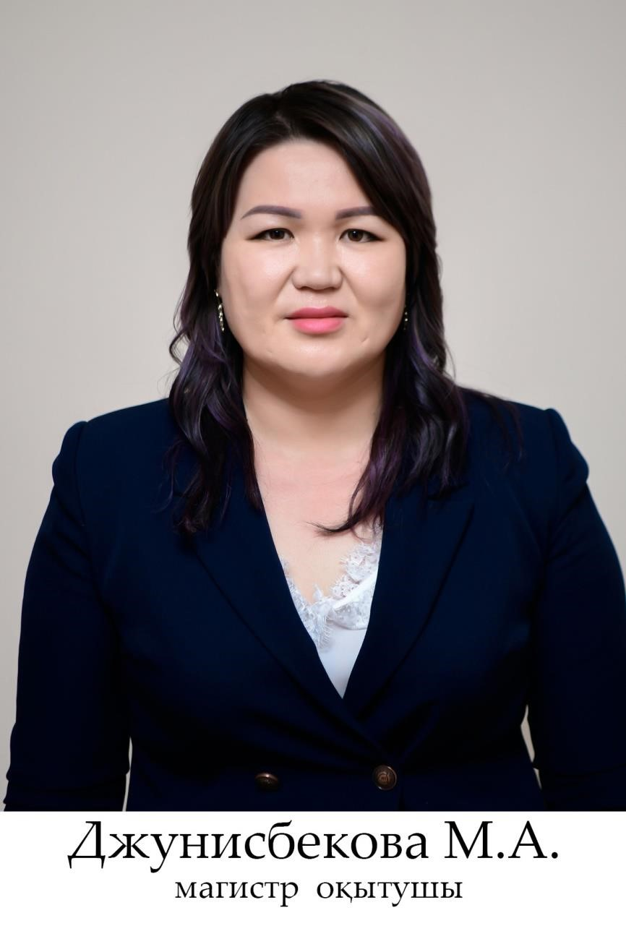

Junisbekova Mayra Artykbaykyzy - Master teacher

aia2008.83@mail.ru

Mobile: +77026042777

Education: Higher

In 2000 she graduated from the secondary school Maktashi Zhetysai.

2000-2004 Graduated from Syrdarya University with a degree in Fine Arts and Drawing.

2012-2014 Graduated from the Master's degree in pedagogy and methods of primary education at Syrdarya University.

Scientific papers: published papers in 8 scientific, scientific-theoretical, international conferences. CAD - 16, LC - 6, UMK-2

Work experience: total work experience of 14 years. Pedagogical, scientific and methodological - 14 years since 2004.

2004-2008 She worked as a teacher at the Syrdarya University.

2011-2012 She worked as a workshop manager at the Center of Decorative and Applied Arts of the South Kazakhstan State Pedagogical University.

2012-2013 Worked as a teacher at the Center of Decorative and Applied Arts of the South Kazakhstan State Pedagogical University.

Since 2013, he has been working as a teacher at the South Kazakhstan State Pedagogical University at the Department of Vocational Training and Fine Arts.

Awards: she was awarded letters of thanks and diplomas for public, industrial, scientific and pedagogical work.

In 2020, OKMPU was awarded a medal in honor of the "80th anniversary" of SKSPU.