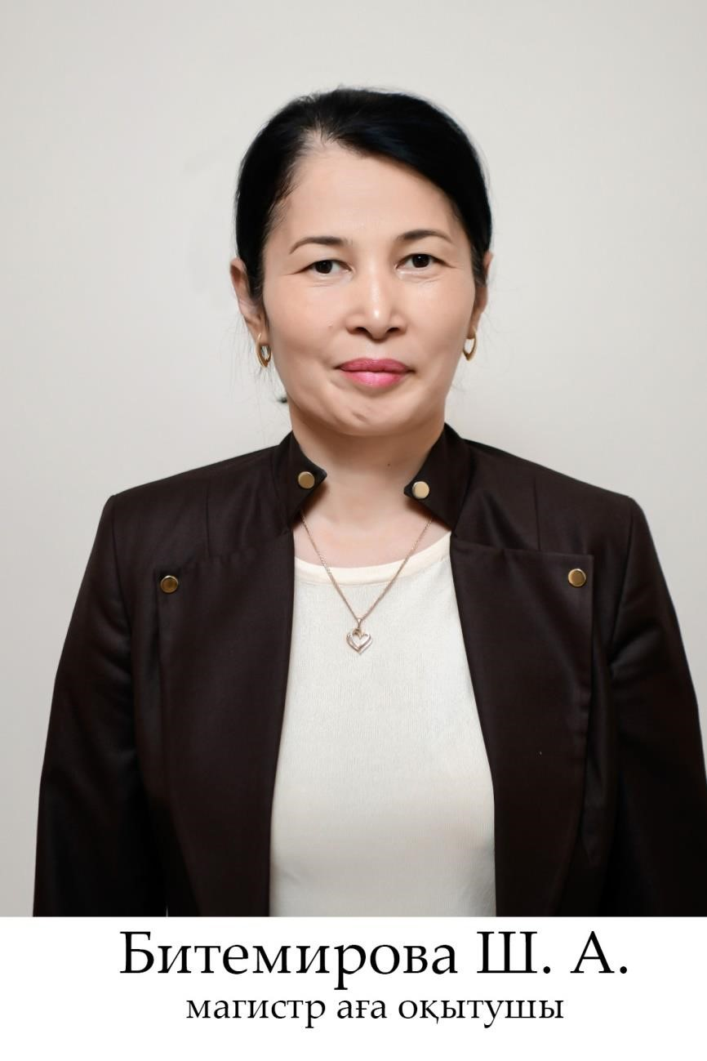

Bitemirova Sholpan Abutobakyzy - Master teacher

bitemirova7979@mail.ru

Mobile communication: +7 707 696 76 19

Education: Higher

In 1986-1996 she graduated from secondary school No. 56 named after Sh . Ualikhanov.

In 1997, she entered the Faculty of Natural Education of the South Kazakhstan Humanitarian University named after M.Auezov, specialty 0321-Labor, in 2001 she graduated from the South Kazakhstan State University named after M.Auezov in this specialty.

In 2018, she entered the doctoral program in the specialty 6D012000-"Vocational Training" at the Department of "Vocational Training" of M. Auezov SKSU on a grant and graduated in 2021.

Scientific papers: published in more than 40 scientific, scientific-theoretical, international conferences. Among them: the control commission in the field of MES RK - 2, RSCI - 2, OP - 8, educational materials - 4, electronic educational materials - 3.

Work experience: total work experience of 46 years. Pedagogical, scientific and methodological - 35 years since 1991.

1996-1997 She worked as a teacher at the E.Yernazarov Secondary School (Temirlan district).

In 1997-2001, she graduated from M.Auezov SKSU with a degree in labor teacher.

2001-2002. received an academic degree of Master of Pedagogical Sciences at the M.Auezov SKSU.

2002-2018 She worked as a senior lecturer at M. Auezov South Kazakhstan State University.

2018-2021 Graduated from the "Professional" department of the M. Auezov SKSU with a degree in 6D012000-"Professional training".

From 2021 to the present, he has been working as a magistrate senior lecturer at the South Kazakhstan State Pedagogical University at the Department of Vocational Training and Fine Arts.

Awards: She was awarded letters of thanks and diplomas for public, industrial, scientific and pedagogical work.

In 2021, she was awarded an Honorary Diploma of the Department of Education of Shymkent.

In 2022, she was awarded a Letter of Thanks from the Department of Culture, Language Development and Archives of the city of Shymkent.