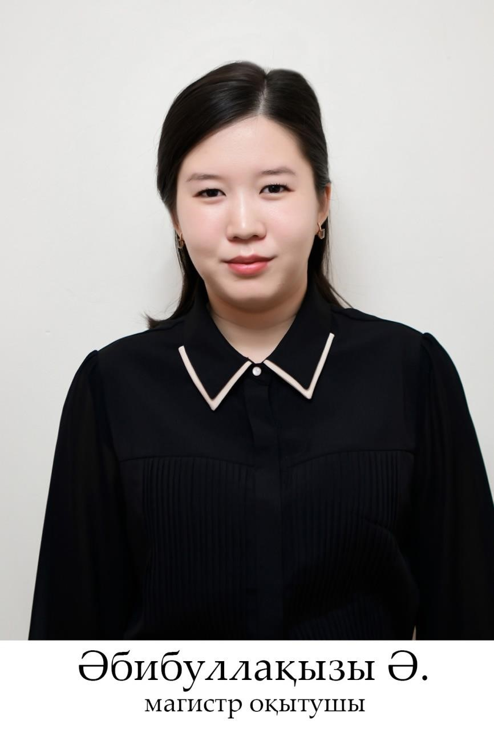

Abibullakyzy Amina – Master teacher

Amina.okmpu22@mail.ru

Mobile communication: +7 777 884 99 04

Education: Higher

2004-2009 at K. Kaziev Elementary School;

2009-2016 Graduated from the Gymnasium No. 65 named after Y. Altynsarina.

2016-2020 Studied at M. Auezov South Kazakhstan State University, Faculty of "Natural Sciences and Pedagogy", specialty "Vocational Training".

2020-2022 She studied at M. Auezov South Kazakhstan University, Faculty of Higher School of Natural Sciences and Pedagogy, specialty "Vocational Training" and received a Master's degree in Pedagogical Sciences.

2022 laboratory assistant at South Kazakhstan State Pedagogical University;

2022 - works as a teacher at the South Kazakhstan State Pedagogical University.

List of scientific papers:

The effectiveness of Distance learning, Materials of the 8th International Conference "Industrial Technologies and Engineering - ICITE-2021" on November 10-11, 2021 at M. Auezov South Kazakhstan University – Shymkent, 2021-Volume 3 (1). pp. 157-158.

Altynsarin's idea of introducing young people to the profession, the series "Pedagogical sciences" of KazHK im. Abylai Khan and ATA. Almaty: Kazgu im. Abylai Khan, No. 2 (61) 2021. pp. 98-104.