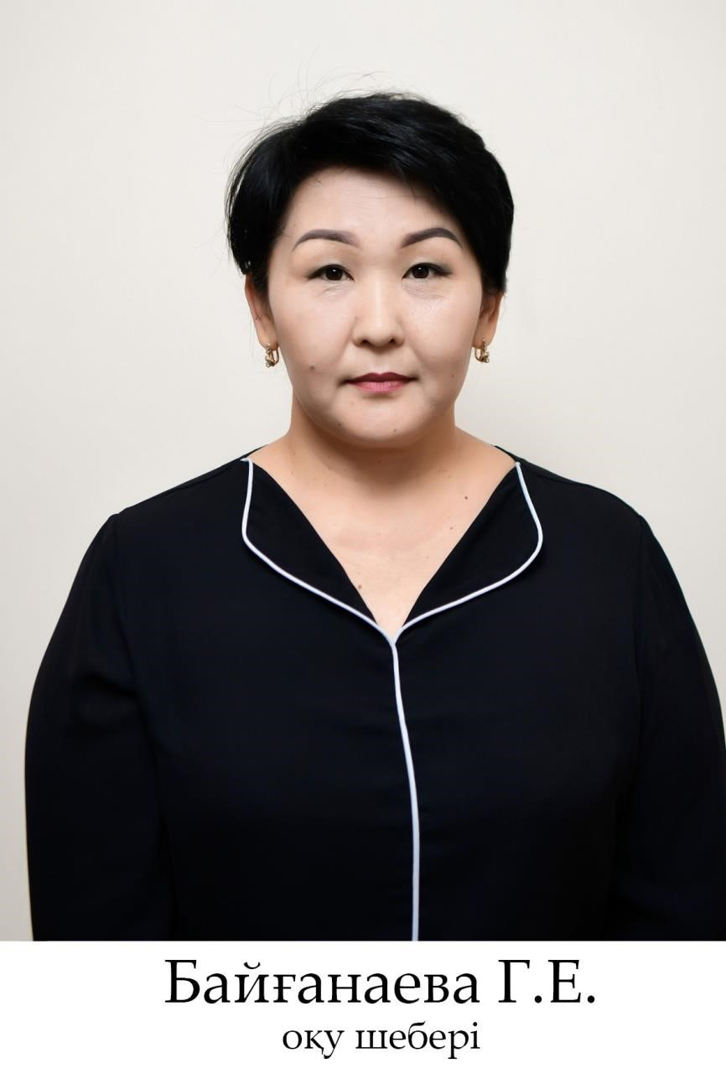

Bayganaeva Gulmira Eleubekovna - training master

kazizo@mail.ru : +7 778 525 04 76

Education: Higher

From 1983 to 1993, S. Aksu of Sairam district graduated from S. Seifullin Secondary School.

In 1993 she entered the International Kazakh-Turkish University named after H. A. Yassawi, in 1997 she graduated from the South Kazakhstan Humanitarian University named after M. Auyezov with a degree in "Professional labor training".

Work experience: 25 years

1997-2003 Worked as a teacher of "Labor" in secondary school No. 47 named after T. Tazhibayev, Shymkent.

In 2005, she was employed as a laboratory assistant at the Department of Decorative Arts of the Kazakh-Turkish University named after Khoja Ahmed Yasawi.

Currently, he works as a training master at the Department of Vocational Training and Fine Arts of the South Kazakhstan State Pedagogical University.

Awards: in 2019, she was awarded a medal in honor of the 80th anniversary of the KSPU.